**Configure VPN client to connect to Wake On Lan server.**

Add subnet 192.168.1.0/24 to remote networks in your WAH profile

1.       Open Shrew Soft VPN Access Manager. Choose vpn profile, right click, choose Properties

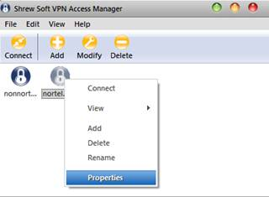

2.       Click Policy tab

3.       In IPSEC Policy Configuration, click Add button

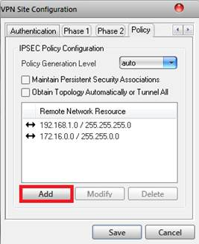

4.       Choose type Include, fill IP address: 192.168.1.0 and subnet mask:255.255.255.0

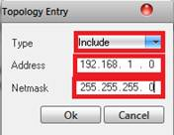

5.       Click OK till all popup windows closed.

## Wake up PC.

1.       Establish VPN tunnel

2.       Go to Wake on lan server: wol.tma.com.vn (192.168.1.70) or wol2.tma.com.vn (192.168.1.41)

3.       Login with TMA credential

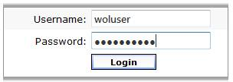

4.       Click on Wake-up and waiting till the PC waked up.

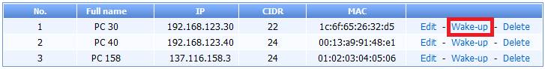

**\*\*\* IMPORTANT: Shutdown remote PC when finished your task.**

1. Windows -> Start -> Run -> type “cmd” then Enter   
2. Type command: shutdown -s -t 0 -f -c "Remote shutdown"

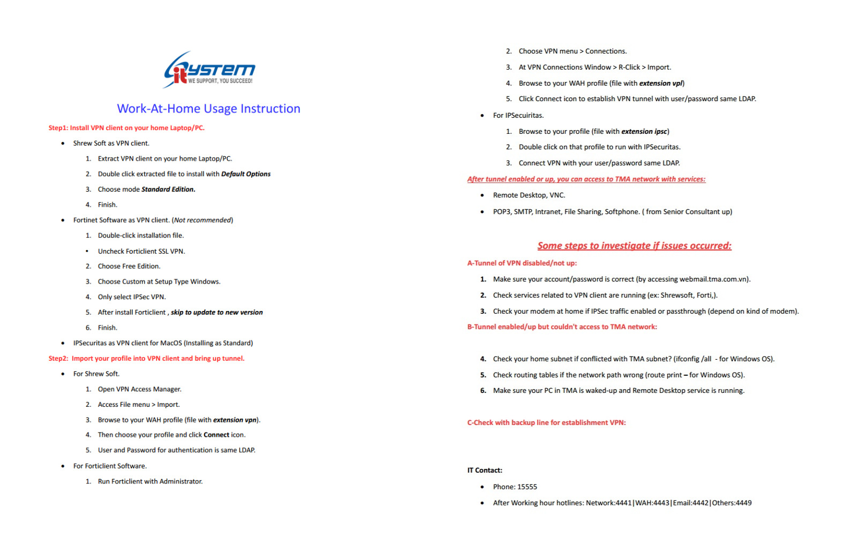

192.168.95.223:88

192.168.72.248